SMART FARMER – IoT ENABLED SMART FARMER APPLICATION MIT APP INVENTOR

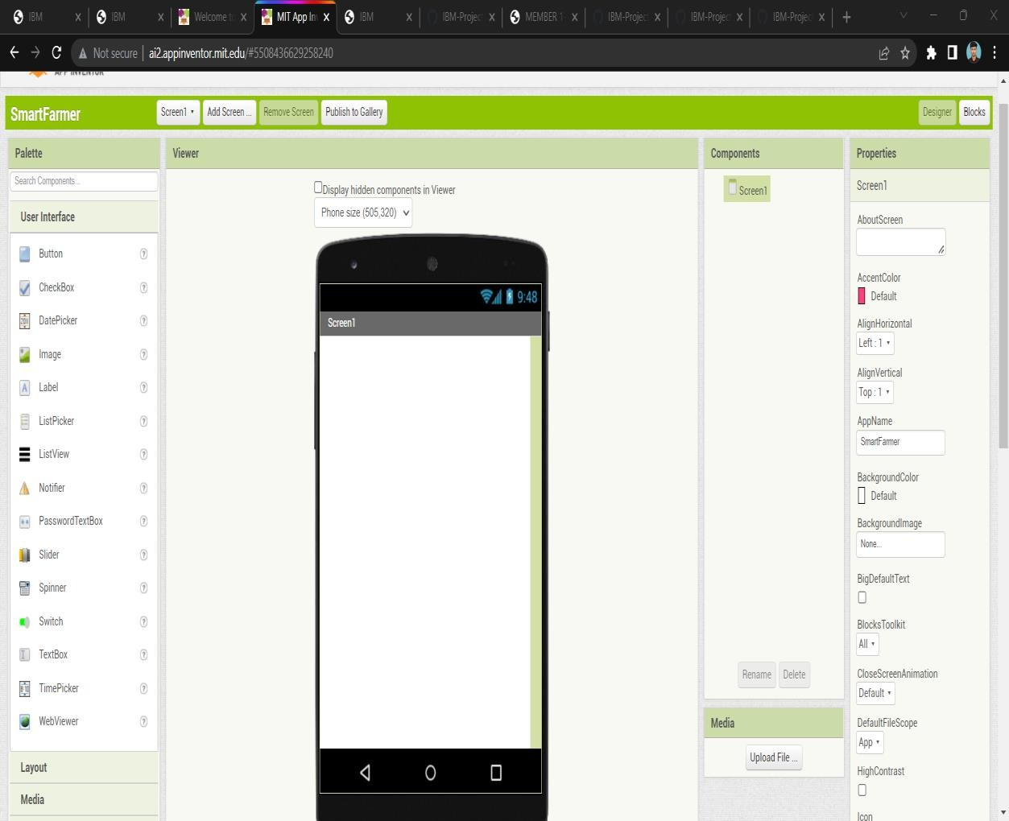

SUBMITTED BY :THENNARASU

ROLL NO : 718020L420

MIT APP INVENTOR APPLICATION DASHBOARD: